Contents

Locate the S3 object for the static content. 2

CloudFront Configuration. 2

Origins Configuration 2

Behavior Configuration 4

Configure Multiple websites in CloudFront

There is need to configure multiple websites (*static content)*  in single CloudFront to share the DNS name.

This can be achieved by configuring CloudFront point to the S3 object path .

## Locate the S3 object for the static content.

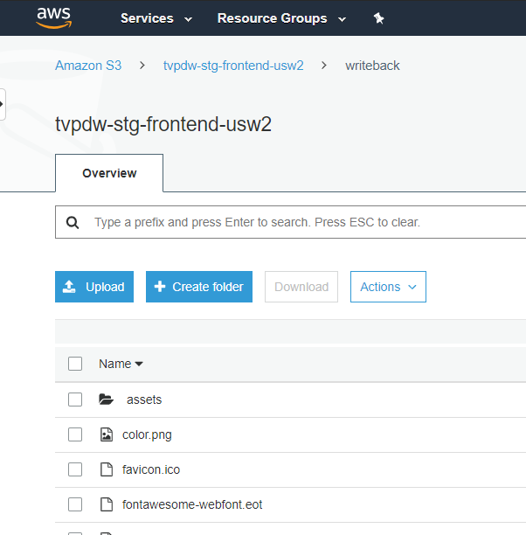

## CloudFront Configuration.

### Origins Configuration

Go to “Origins and Origin Groups” Tab and select Create Origin

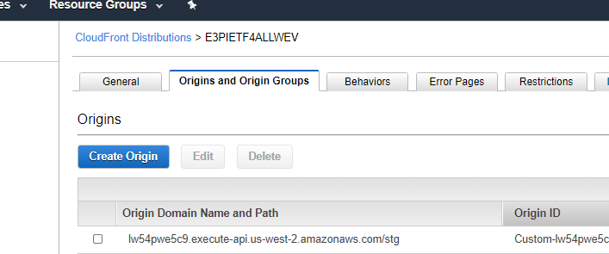

In Create Origin popup

1. Select S3 bucket where the static content is stored. I have selected tvpdw-stg-frontend-usw2.s3.amazonaws.com in example below.

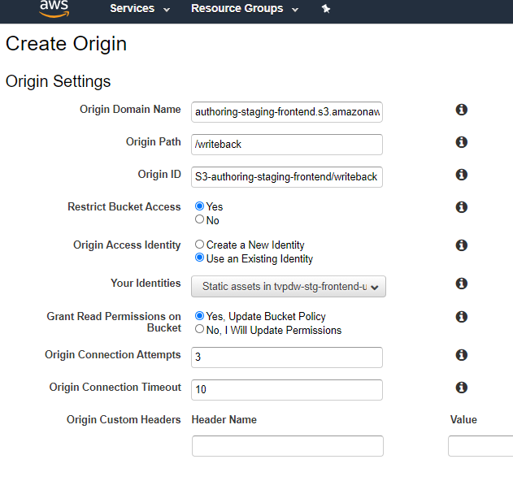

1. In the Origin path enter the folder name from S3 bucket where the content of other application is stored. Here I have entered *writeback* as a folder name. **Note the / (slash) in the folder name.**
2. Select the Existing Origin Access Identiy. Select the one created for main application as we are storing the static content in the same bucket for main (RECAP) and secondary (Writeback) application.
3. Set the rest of the parameters as shown in the attached image.
4. Click on Create button.

### Behavior Configuration

Navigate to Behavior tab and select Create Behavior tab

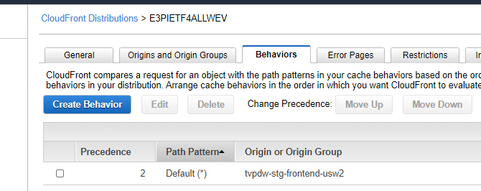

In the Create Behavior popup

1. Specify which requests you want to route to the origin in Path Pattern text box. I have entered */writeback/\** indicating route all the requests starting with *writeback/*  to be routed the defined Origin.

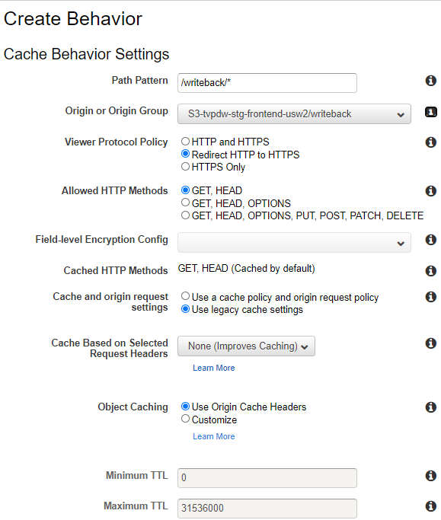

1. Select the Origin ID defined in Origins tab.
2. In Viewer Protocol Policy , select Redirect HTTP to HTTPS
3. In Cache and origin request settings , select Use legacy cache settings
4. In Compress Objects Automatically select Yes to allow CloudFront compression.
5. Click on Create.

Wait for Invalidation to complete for the CloudFront.